**cross join vs full outer join**

**nested joins in sql**

**What is a Merge Join in SQL Server?**

**what is the difference between merge and union all transformation in sql?**

**cursor in sql**

**merge vs union in sql**

**merge vs full outer join**

**SQL vs T-SQL vs PL\SQL**

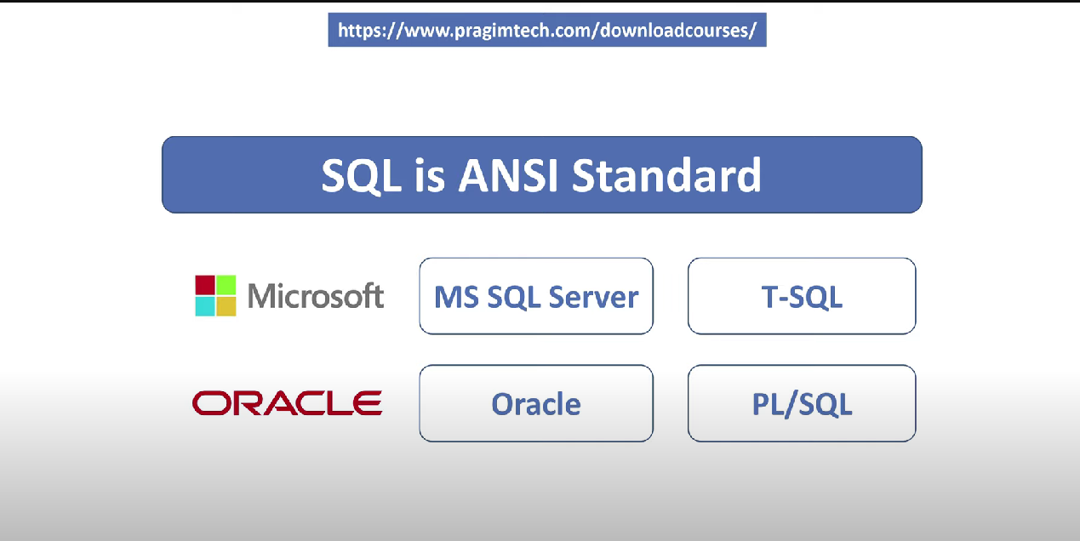

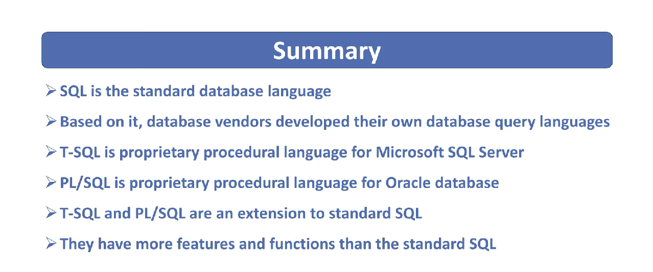

**cast vs convert in sql**

CONVERT is SQL Server specific, CAST is ANSI.

CONVERT is more flexible in that you can format dates etc. Other than that, they are pretty much the same. If you don't care about the extended features, use CAST.

**patindex vs charindex**

The PatIndex function is used with the wildcard characters. You must enclosed the wildcard characters before (when searching at last) or after (when looking for first) the searching text.

But, the CharIndex function can not be used any wildcard characters with the specified searching pattern. In the CharIndex function will not work upon the  wildcard characters.

Example of PatIndex

SELECT (PATINDEX('%Corner%', 'C-SharpCorner'))

**Will result 8.**

Example of CharIndex

SELECT (charindex('Corner', 'C-SharpCorner'))

**Will also result 8.**

# SQL Server STUFF() Function

The STUFF() function deletes a part of a string and then inserts another part into the string, starting at a specified position.

SELECT STUFF('SQL Tutorial', 1, 3, 'HTML');

-- Delete 3 characters from a string, starting in position 1, and then insert "HTML" in position 1:

SQL Server PATINDEX() Function

Return the position of a pattern in a string:

SELECT PATINDEX('%schools%', 'W3Schools.com');

=======================================================

**How to find nth highest salary in sql**

db.products.find().sort({price:-1}).skip(n-1).limit(n-1)

with Emp as

(

select *,DENSE_RANK() over (order by salary desc) as RankID from Employee

)

select top 1 * from Emp where RankID=N

**How to find 1th highest salary in sql**

db.products.find().sort({price:-1}).limit(1)

select max(Salary) from Employee

**How to find 2th highest salary in sql**

db.products.find().sort({price:-1}).skip(1).limit(1)

**How to find 15th highest salary in sql**

db.products.find().sort({price:-1}).skip(15-1).limit(15-1)

*********************************************************

**SQL query to get organization hierarchy**

with Emp as

(

select EmployeeID,Name,Salary,ManagerID from Employee where EmployeeID=1

union all

select Employee.EmployeeID, Employee.Name,Employee.Salary,Employee.ManagerID from Employee join Emp on Employee.EmployeeID=Emp.ManagerID

)

select EmployeeID,Name,Salary,ManagerID from Emp

*****************************************************************

**Delete duplicate rows in sql**

WITH EmployeesCTE AS

(

SELECT *, ROW_NUMBER()OVER(PARTITION BY Name ORDER BY EmployeeID) AS RowNumber

FROM Employee

)

Delete from EmployeesCTE where RowNumber>1

*****************************************************************

**SQL query to find employees hired in last n months**

select *,DATEDIFF(MONTH,HireDate,GETDATE()) as datediffnum from Employee

where DATEDIFF(MONTH,HireDate,GETDATE()) between 1 and 12

*****************************************************************

**Transform rows into columns in sql server**

select country , city1,city2,city3 from

(

select *,'City'+ cast(ROW_NUMBER() over(partition by Country order by City) as nvarchar(10)) as CityID from Countries

) tmp

pivot

(

MAX(City) for CityID in(city1,city2,city3)

) as pivottable

*****************************************************************

**SQL query to find rows that contain only numerical data**

SELECT Value FROM TestTable WHERE ISNUMERIC(Value) = 1

*****************************************************************

**SQL Query to find department with highest number of employees**

select Department.Name, count(Employee.EmployeeID) from Department

inner join Employee on Department.DepartmentPID=Employee.DepartmentPID

group by Employee.DepartmentPID,Department.Name

*****************************************************************

**Difference between inner join and left join**

*****************************************************************

**Can we join two tables without primary foreign key relation**

Yes, we can join two tables without primary foreign key relation as long as the column values involved in the join can be converted to one type.

*****************************************************************

**Difference between blocking and deadlocking**

Blocking : Occurs if a transaction tries to acquire an incompatible lock on a resource that another transaction has already locked. The blocked transaction remains blocked until the blocking transaction releases the lock.

Deadlock : Occurs when two or more transactions have a resource locked, and each transaction requests a lock on the resource that another transaction has already locked. Neither of the transactions here can move forward, as each one is waiting for the other to release the lock. So in this case, SQL Server intervenes and ends the deadlock by cancelling one of the transactions, so the other transaction can move forward.

*****************************************************************

**Sql query to select all names that start with a given letter without like operator**

SELECT * FROM Employee WHERE Name LIKE 'M%'

SELECT * FROM Students WHERE CHARINDEX('M',Name) = 1

SELECT * FROM Students WHERE LEFT(Name, 1) = 'M'

SELECT * FROM Students WHERE SUBSTRING(Name, 1, 1) = 'M'

*****************************************************************

**Sql date interview questions**

Write a SQL query to get

**1. All people who are born on a given date (For example, 9th October 2017)**

SELECT Name, DateOfBirth, CAST(DateOfBirth AS DATE) AS [DatePart]

FROM Employees

WHERE CAST(DateOfBirth AS DATE) = '2017-10-09'

**2. All people who are born between 2 given dates (For example, all people born between** Nov 1, 2017 and Dec 31, 2017)

SELECT Name, DateOfBirth, CAST(DateOfBirth AS DATE) AS [DatePart]

FROM Employees

WHERE CAST(DateOfBirth AS DATE) BETWEEN '2017-11-01' AND '2017-12-31'

**3. All people who are born on the same day and month excluding the year (For example, 9th October)**

SELECT Name, DateOfBirth, CAST(DateOfBirth AS DATE) AS [DatePart]

FROM Employees

WHERE DAY(DateOfBirth) = 9 AND Month(DateOfBirth) = 10

**4. All people who are born yesterday, today, tomorrow, last seven days, and next 7 days**

--yesterday

SELECT Name, DateOfBirth, CAST(DateOfBirth AS DATE) AS [DatePart]

FROM Employees

WHERE CAST(DateOfBirth AS DATE) = DATEADD(DAY, -1, CAST(GETDATE() AS DATE))

--tomorrow

SELECT Name, DateOfBirth, CAST(DateOfBirth AS DATE) AS [DatePart]

FROM Employees

WHERE CAST(DateOfBirth AS DATE) = DATEADD(DAY, 1, CAST(GETDATE() AS DATE))

--yesterday and today\since yesterday

SELECT Name, DateOfBirth, CAST(DateOfBirth AS DATE) AS [DatePart]

FROM Employees

WHERE CAST(DateOfBirth AS DATE)

BETWEEN DATEADD(DAY, -1, CAST(GETDATE() AS DATE))

AND CAST(GETDATE() AS DATE)

--last 7 days (excluding today)

SELECT Name, DateOfBirth, CAST(DateOfBirth AS DATE) AS [DatePart]

FROM Employees

WHERE CAST(DateOfBirth AS DATE)

BETWEEN DATEADD(DAY, -7, CAST(GETDATE() AS DATE))

AND DATEADD(DAY, -1, CAST(GETDATE() AS DATE))

--today

SELECT Name, DateOfBirth, CAST(DateOfBirth AS DATE) AS [DatePart]

FROM Employees

WHERE CAST(DateOfBirth AS DATE) = CAST(GETDATE() AS DATE)

**5. All people whose birth year is the same (For example, all people born in 2017, 2018 etc.)**

SELECT Name, DateOfBirth, CAST(DateOfBirth AS DATE) AS [DatePart]

FROM Employees

WHERE YEAR(DateOfBirth) = 2017

*****************************************************************

**Sql query to delete from multiple tables**

Alter table Employees

add constraint FK_Dept_Employees_Cascade_Delete

foreign key (DeptId) references Departments(Id) on delete cascade

*****************************************************************

**Sql function to get number from string**

Create function UDF_ExtractNumbers

(

-- Input is alphanumeric string

@input varchar(255)

)

-- Returns numbers as a string

Returns varchar(255)

As

Begin

-- Returns the index of a character that is not a number

-- If the specified pattern is not found, ZERO is returned

Declare @alphabetIndex int = Patindex('%[^0-9]%', @input)

Begin

While @alphabetIndex > 0

Begin

-- In the input string (@input) at the position (@alphabetIndex)

-- where we have a non-numeric chracter, replace that 1

-- character with an empty string ('')

Set @input = Stuff(@input, @alphabetIndex, 1, '' )

-- Find the next non-numeric character and repeat the above step

-- until all non-numeric characters are replaced with an empty string

Set @alphabetIndex = Patindex('%[^0-9]%', @input )

End

End

Return @input

End

Select dbo.UDF_ExtractNumbers(IDName) as ID as Numbers from TestTable

Create function UDF_ExtractAlphabets

(

-- Input is alphanumeric string

@input varchar(255)

)

-- Returns numbers as a string

Returns varchar(255)

As

Begin

-- Returns the index of a character that is not an alphabet

-- If an alphabet is not found, ZERO is returned

Declare @numberIndex int = Patindex('%[^a-zA-Z]%', @input)

Begin

While @numberIndex > 0

Begin

-- In the input string (@input) at the position (@numberIndex)

-- where we have an alphabetic chracter, replace that 1 alphabetic

-- character with an empty string ('')

Set @input = Stuff(@input, @numberIndex, 1, '' )

-- Find the next alphabetic character and repeat the above step

-- until all alphabetic characters are replaced with an empty string

Set @numberIndex = Patindex('%[^a-zA-Z]%', @input )

End

End

Return @input

End

Select dbo.UDF_ExtractAlphabets(IDName) as Name from TestTable

Select dbo.UDF_ExtractNumbers(IDName) as ID, dbo.UDF_ExtractAlphabets(IDName) as Name from TestTable

*****************************************************************

**Sql server select where in list**

Declare @FirstNamesList nvarchar(100) = 'Mark,John,Sara'

SELECT * FROM Employees where FirstName IN (SELECT * FROM STRING_SPLIT(@FirstNamesList, ','))

Declare @FirstNamesList nvarchar(100) = 'Mark,John,Sara'

SELECT Employees.* FROM Employees

JOIN STRING_SPLIT(@FirstNamesList, ',') Result

ON Result.VALUE = Employees.FirstName

*****************************************************************

**Sql select most repeated value**

select Name from Employee GROUP by name having count(Name) >1